Name: Anita
Family name(s): Smith
Identity document:
Type: Passport
Number: Y2369480K
Issuing country: United Kingdom
Postal address: Carrer de Mallorca, 180, 08036 Barcelona
Further information: +34 693 455 293

I DECLARE:
- I am a student from the University of Sheffield, United Kingdom, currently on an Erasmus+ programme at the University of Barcelona.
- On 25 September I registered in a Catalan for Beginners course at the Language Services and on the same day I paid the full course fee (€225).
- I was subsequently informed that as a mobility student I am entitled to free basic language tuition.

I REQUEST:
A refund of €225.

SUPPORTING DOCUMENTS
- Photocopy of passport
- Photocopy of Erasmus+ learning agreement
- Photocopy of Language Services registration form
- Photocopy of proof of payment from the bank

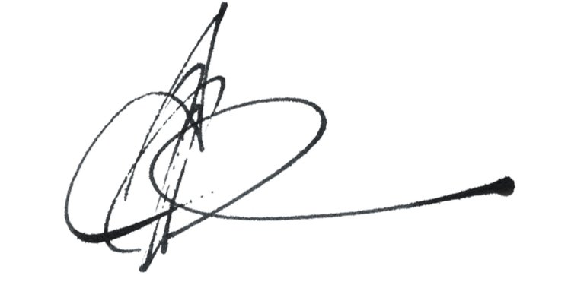

Barcelona, 15 October 2021
__________________________
Language Services
University of Barcelona

