Curriculum Vitae
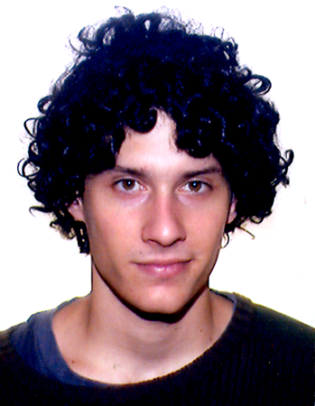

(September 2012)
Personal Data
Name | Aurélien Darbellay
Date and place of birth: | 27/11/1983, Geneva
Nationality | Swiss
Current position | FPU graduate research fellow at the Universitat de Barcelona.
Address | c/St-Vicenç, 5, Ático, 08001, Barcelona
ID | X-7780720-G (NIE); X1463604 (Passport)
Affiliation
Student member of LOGOS, Universitat de Barcelona, September 2011 - present
Education
2011- | PhD in Philosophy at the Universitat de Barcelona (APhil program).
2010-2011 | Master degree at the Universitat de Barcelona (APhil program).
2006-2010 | Bachelor degree in Sociology at the Universitat Autònoma de Barcelona
Areas of interest
Metaphysics, Metametaphysics, Philosophical Logic, Ethics, Philosophy of Language
Participation in Workshops
- Comments on “The Transparency of Linguistic Content” by Gregory Bochner , 4th Jean Nicod & LOGOS Workshop, March 2012, Paris.
- Comments on “ Mereological Indeterminacy: Metaphysical but not Fundamental” by Thomas Sattig, III PERSP Metaphysics Workshop, September 2012, València.
- “Concepts of Existence”, 1st HU & LOGOS Workshop on Metametaphysics, November 2012, Berlin.

Work in progress
‘Reference and social kinds’ : on Hasslanger and Thomasson’s views related to the possible opacity of terms referring to social kinds.
‘Concepts of Existence’ : on Quantifier Variance and, particularly, against Eklund’s criticism of the multitude assumption.
‘Extending moral domain beyond reason’ : against Dworkin’s reduction of Metaethics to first-order moral reasoning.
‘The limits of social world: grounding social properties’: I argue that the social domain should be delimited by the instantiation of some specific properties, the social properties, which I identify as those properties grounded in collective intentionality.

