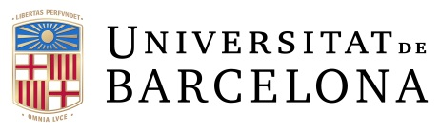 |  | Oficina de Projectes  Internacionals de Recerca (OPIR)

UB International Research Projects Office offers you Tailor Made Seminars about European and International Research Funds.

You can select what type of Seminar you would like to organize by checking different boxes on the first 3 sections. If none of them suits you, make your own proposal in the section 4.

1. INTRODUCTION

General HORIZON EUROPE overview
Specific HORIZON EUROPE Programme
Others (specify):

2. GETTING TO THE POINT

How to write a proposal (general)
How to write an ERC/MSCA/other programme proposal
How to write a specific part of the proposal (i.e. impact, implementation…)
Others (specify):

3. PRACTICAL INFORMATION

Where can I find the information and how works the EC Funding & Tender Opportunities Portal?
Individual interviews
Others (specify):

4. MY OWN PROPOSAL (please write your seminar necessities)

Please specify the target (research group, department, etc.) and
the number of participants (approx.).

Send this form by mail to recerca.europea@ub.edu
or call us at 93 40(39980)

