 | 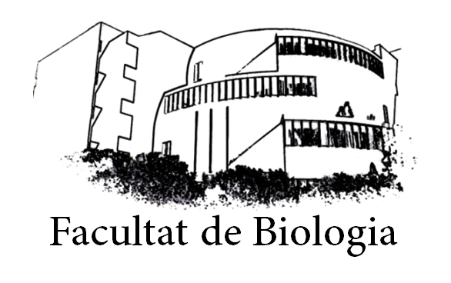 | Coordinació de Pràcticums i TFG  (Internacionals)  Facultat de Biologia  Avgda. Diagonal 643  08028 Barcelona  practicum.erasmusbio@ub.edu
RESEARCH PROJECT FORM

MANDATORY PRACTICAL TRAININGS OF UNDERGRADUATE STUDENTS AT FACULTY OF BIOLOGY- UNIVERSITAT DE BARCELONA
Student’s name and surname:
Academic Year
Host University
School/Department
Research Group
Principal Investigator: |  | email
Principal Investigator: |  | TF
Research tutor:  (if different) | Name:
Project Title:
Brief Summary:
(100 - 200 words)
Main techniques and systems used:

To be filled at UB:
Internal Tutor | Name: | Email:
Internal Tutor | Name: | Tel:
Coordinator of International student mobility  Faculty of Biology | Name: Marta Camps | Email: martacamps@ub.edu  ori-bio@ub.edu
 | Name: Marta Camps | Tel: +34 93 4034827
Coordinator of International placements  Faculty of Biology | Name: Cristina Madrid | Email:  practicum.erasmusbio@ub.edu
Coordinator of International placements  Faculty of Biology | Name: Cristina Madrid | Tel: +34 93 4034827

